VERZEO

(Major Project)

Name: Dhanuj Tomar

Task 1:

Manage a password in Azure Key Vault.

Solution:

To create a key vault, we would need any basic subscription.

We can also create key vaults using Azure Sandbox.

**Azure Key Vault is a resource that helps you securely store and access your keys, secrets and certificates.**

To store your Key you need to create a key vault:

* Navigate to azure key vault and fill the given form as per your requirements

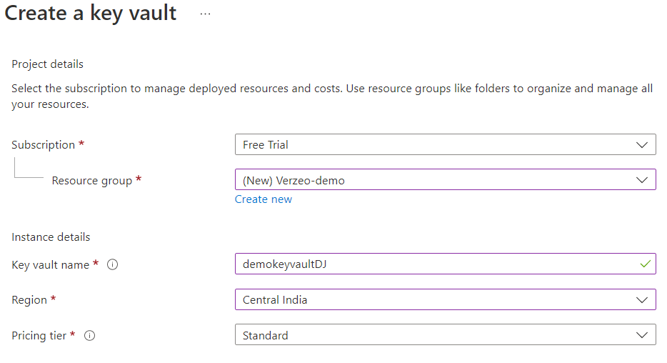

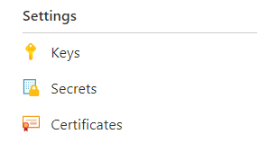

Once you have create a key vault now is time to choose a service that you want: **Some of the basic services are keys, secrets and certificates.**

We are going to **create a secret** to manage our password.

1. Click add a secret button in the secret tab located in the key vault.
2. Fill the form and enter your password (Vaule).
3. Click create.

Accessing password

1. To access your password select the secret you want to access from the secret tab
2. Select the version that you want to access
3. Click show secret value to view your password.

Task 2:

Create a SQL database

Solution:

To create a SQL Database.

1. Search for SQL Database
2. Click the create button to create new SQL DB.
3. Fill in the form given
4. Keep sure to select a compute storage as per your requirement. **It is a payable service.**

1. Select a storage redundancy – How secure you want to keep your data. (This may contain extra charges)

**If you don’t have a SQL Server already deployed:**

1. Select the create new button
2. Fill the form
3. Choose the authentication method, You can choose whether to use a SQL Authentication or Azure AD or both.

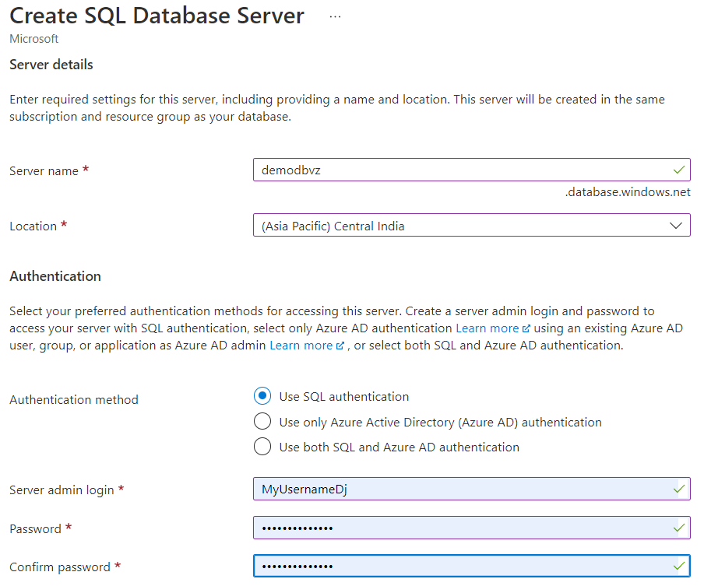

1. Review + Create

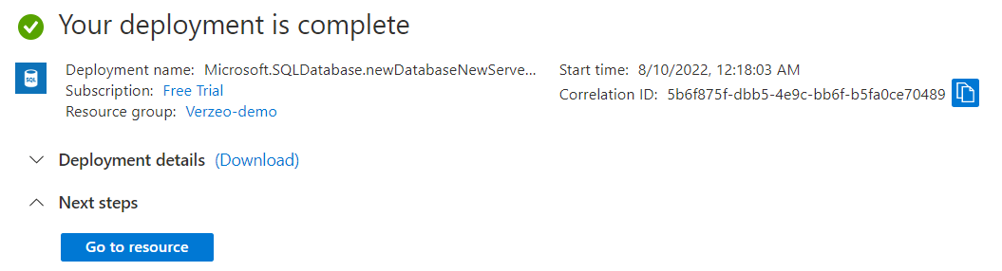

Task 3:

Create a simple chatbot using the Azure QnA maker service

Solution:

Video Recording

Task 3:

Create a computer vision resource for OCR (Optical character recognition) and perform OCR on the images as mentioned in this Microsoft Docs reference link :

1. Read the text using OCR on all three images as mentioned
2. Detect and analyze faces using the cognitive services.

Solution:

Video Recording